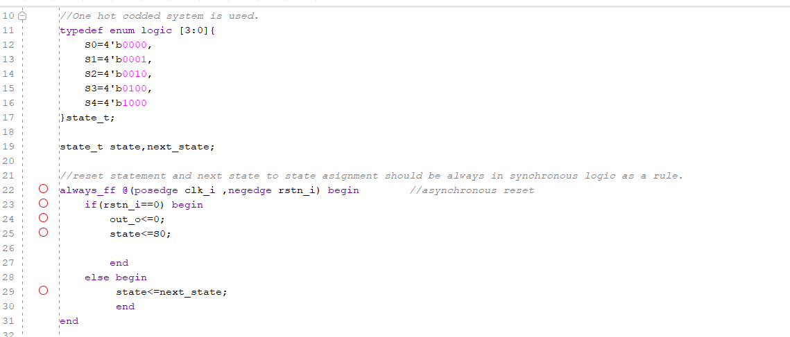
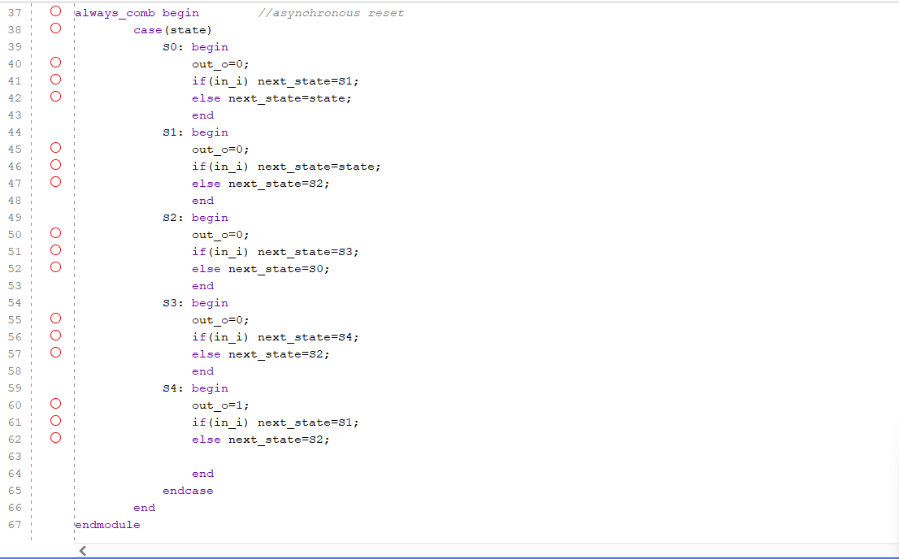
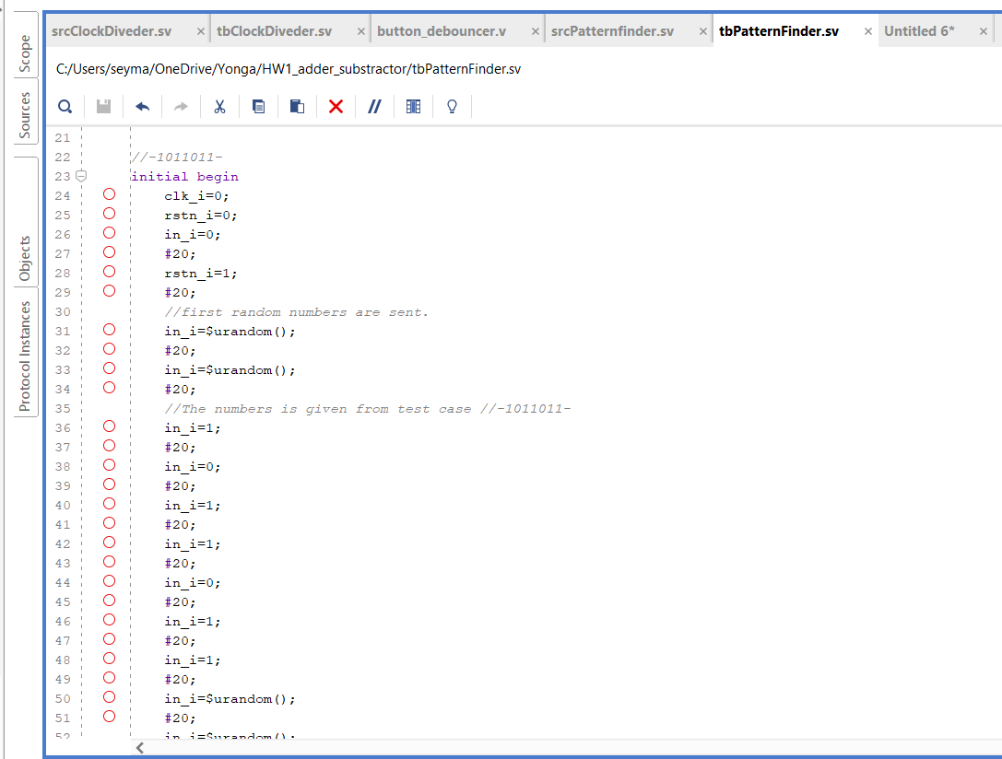
Source file
Testbench file
Pattern Finder
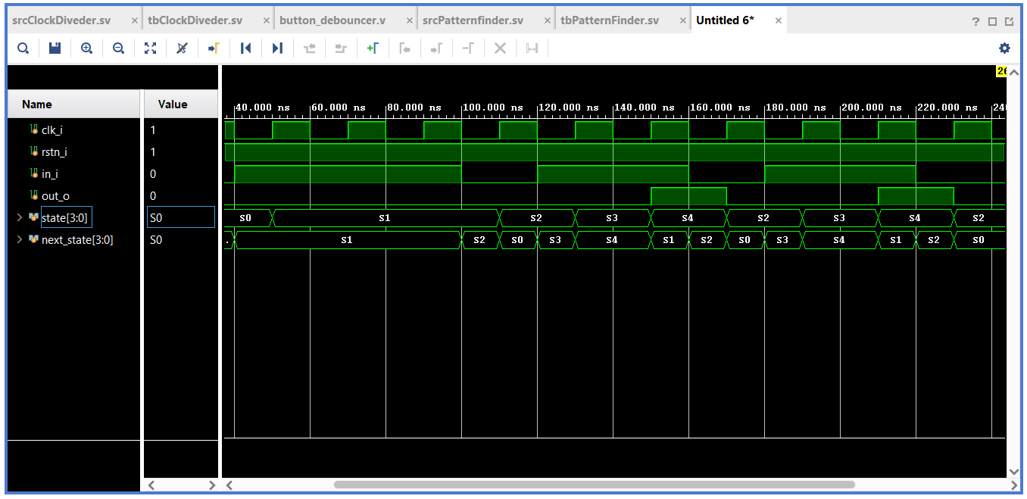
Moore machine is used for this design to see output since in moore machines on output only depends on current states it doesnt depend on inputs. In our design output is only high at the last state so it only depends on currents states.
Simulation

